ST MICHAEL AND ALL ANGELS MEDITATION: 2-4pm GOOD FRIDAY 2020

Name and time:

Chris 2pm-2.10
Nikki 2.10-2.20
Carole 2.20-2.30
Ian 2.30-2.40
Victor 2.40-2.50
Jenny 2.50-3pm
Kate 3-3.10
Jan 3.10-3.20
Fiona 3.20-3.30
Diane & John 3.30-3.40
Stella 3.40-3.50
Dave 3.50-4pm

Blessing by Roger and Lynne

Prayers and meditations

† 2pm-2.10 Chris’s prayer

Dear God
Help us to help others
There are things happening all around us right now that make us feel weak, helpless, and afraid.
Even in the middle of this I know you are the Lord
I know the situation is in your hands and I trust you
I ask you for strength and wisdom that we may all be able to endure
Fill us with the wonder of your goodness replacing self-doubt with confidence in you and your sure and steady help. Amen.

†2.10-2.20 Nikki’s prayer: A Hymn to God the Father by John Donne

WILT Thou forgive that sin where I begun,
Which was my sin, though it were done before?
Wilt Thou forgive that sin, through which I run,
And do run still, though still I do deplore?
When Thou hast done, Thou hast not done,
For I have more.

Wilt Thou forgive that sin which I have won
Others to sin, and made my sin their door?
Wilt Thou forgive that sin which I did shun
A year or two, but wallowed in a score?
When Thou hast done, Thou hast not done,
For I have more.

I have a sin of fear, that when I have spun
My last thread, I shall perish on the shore ;
But swear by Thyself, that at my death Thy Son
Shall shine as he shines now, and heretofore ;
And having done that, Thou hast done ;
I fear no more.

†2.20-2.30 Carole’s prayer:

A Light to Guide the Way
When the winter days are fading and the Spring comes forth anew,
The gifts that fill this wonderful world, once again come shining through.
The daffodils are blooming and the birdsongs fill the breeze
The skies are blue above us and the leaves form on the trees.

In a wave of desolation, a disease has swept the world
It has reached into every corner and its talons have unfurled.
It has no respect for riches, colour, creed or age
It frightens us regardless and fills us all with rage.

In the dark days of isolation, when people feel so blue
The loneliness surrounds us, there is little we can do.
Like a blanket, you enfold us and brighten up the day
Giving promise, love and hope, a light to guide the way.

Our beautiful world seems broken, our hopes turned to despair,
It would be easy to convince ourselves he’s not listening to our prayer.
But he’s always there beside us, he hears us when we pray
Our faith in God the Father will never go away.

The sadness of Good Friday, a loss that’s hard to bear
The suffering of Jesus, we were never promised fair.
But cometh Easter Sunday, when life starts anew.
This path we visit yearly, with praise and thanks to you.

Be thankful for each other, neighbour, family and friend,
Encourage, support and care until this fearful time comes to an end.
Then look back, reflect, continue, value those that helped you through
Out of despair comes love and hope, a community anew.

Our Father, please listen and hear us when we pray and keep safe our loved ones each and every day. Amen

†2.30-2.40 Ian’s prayer:

I pray especially for Rev Paul and our church family. For my family and friends and loved ones. For our dear Queen and her family and all our NHS and care workers. Please protect all of them and keep them safely in your loving care.
With loving thanks.
Amen

†2.40-2.50 Victor’s prayer:

Father, we thank you for everything you have given to us.

We’re living in a time of uncertainty and we cannot predict the outcome. You are Our Father, through all the changing scenes of life, in trouble and in joy. We praise and glorify You. We magnify and exalt your Holy Name.

Merciful Father, we ask that you rescue us from fear and distress at this Easter time. We rest our hope and trust on You. Please shield and protect us from all illness and harm.

Oh Lord, we have tasted your kindness and have seen that you are good. Keep us in your confide. We fear you and know we have nothing else to fear.

Let us delight in God’s Holiness. Loving Lord, preserve us and keep our families and loved ones safely in your care.

†2.50-3pm Jenny’s video (hold down CONTROL and click on the link)

https://www.youtube.com/watch?v=ae6AMjMH8zA

†Jenny’s prayer:

A prayer for Good Friday
Jesus,

Today we pause to remember your sacrificial love
That shone light into the darkness
That bore life from such emptiness
That revealed hope out of devastation
That spoke truth through incrimination
That released freedom in spite of imprisonment
And brought us forgiveness instead of punishment.

Thank you that we can now walk in the light of your life,
Hope, truth, freedom and forgiveness,
This day and every day.

†3-3.10 Kate’s prayer:

Dear Lord, as we have gone through Holy Week we see so many things that we can compare with our world today.

We see the confusion and fear of your disciples as they try to understand what was about to happen to your son and we too are feeling this way about our world and our lives in this time of uncertainty.

Your Son made the ultimate sacrifice for us on the cross and we see so many key workers today making their sacrifice to nurse the sick, to keep the country fed, to comfort those who mourn loved ones, the emergency services and all who are keeping our country going during such troubling times.

We like Jesus mother Mary and his friends are keeping our vigil waiting for how our lives will be in the coming days.

On Easter Sunday we will celebrate your Son’s resurrection and we look forward to the resurrection of our lives and our world as we strive to overcome all that has happened in the last few weeks and will happen over the coming weeks and months.

Dear Lord give us the strength and hope to carry on in faith and love and as your church here in Birchwood, help us to help others in any way we can.

And finally, we thank you for the gift of eternal life given to us that we know that we all have a place waiting for us in Heaven and Eternal Life.

Lord God bless us all. Amen.

†3.10-3.20 Jan’s prayer:

Living God.
Draw us deeper into your love
Jesus our Lord
Send us to love and care
Holy Spirit
Make us heralds of good news.
Stir and strengthen us
Teach and inspire us
To live your love
With generosity and joy
Imagination and courage
For the sake of your world
And in the name of Jesus. Amen.

†3.20-3.30 Fiona’s meditation:

I can’t wait for a year’s time, when all of this is hopefully a distant memory and there is a corona baby boom because all the lovers were loving

And there will be a rise in small businesses because all the entrepreneurs had a moment of stillness and creativity

And all our children will remember nothing but a time when all the Mums and Dads were at home drawing and playing board games and we remember it as the time we all got to stop and be present
We will remember the time our health was our first priority and people learnt new ways to use fresh produce to feed their families and we were all forced to think outside the box and dream up new things and reinvent old ways and for once, even amongst the chaos, there was community, there was a global rise in togetherness, and the streets were quiet but our homes were bursting with love and laughter.
The time is coming…soon just like other crisis before it, this will all be a distant memory, a thing we soon listen to our children discuss in classrooms, a once was; that we share with our grand babies. So to you - I know it’s unsettling but focus on the silver lining, we are in this together and there’s so much beauty to see.

†3.30-3.40 Diane and John’s prayer:

Make me a channel of your peace,
Where there's despair in life let me bring hope,
Where there is darkness, only light
And where there's sadness ever joy

†3.40-3.50 Stella’s prayer:

Lord you walk beside me, you are always there.
Come be in my waking, go with me everywhere.
Lord your hand will guide me, your light will show the way
Come be in my thinking, be my guide today.

†3.50-4pm Dave’s meditation and prayer:

“God so loved the world that he gave his only begotten Son, that whosoever believes in him, should not perish but have everlasting life” John 3: 16

This fundamental statement, from St. John’s Gospel, encapsulates the whole meaning of Christianity. God, in human form, places Himself in the hands of His Creation and suffers for us, so that we may too experience the extent of His love and the ultimate joy of everlasting life.

The love of God, as seen in the statement from John, is something we need to take into our hearts and ponder; on what is the fundamental truth of Christianity. If we believe in this truth how can we fear the future.

O Lord, we thank you for the ultimate sacrifice you made for us on the cross. Please still in our hearts that faith which acknowledges above all other what you have done for us. Please help us to use that faith in our lives when the times ahead appear beyond our control and the future looks bleak. Guide us, with courage and faith, the way forward so that we may help others as well as ourselves to see this path, through Jesus Christ our Lord. Amen

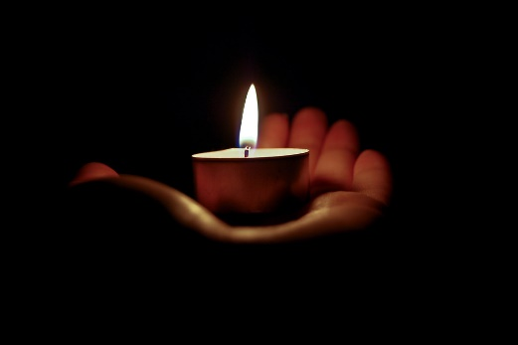

† A verse from a hymn by Stuart Townend from Wendy:

My heart is filled with thankfulness
To him who walks beside
Who floods my weaknesses with strength
And causes fear to fly
Whose every promise is enough
For every step I take
Sustaining me with arms of love
And crowning me with grace
†The Blessing from Roger and Lynne:

The Lord bless you and keep you
The Lord make his face to shine upon you, and be gracious unto you
The Lord lift up the light of his countenance upon you and give you peace

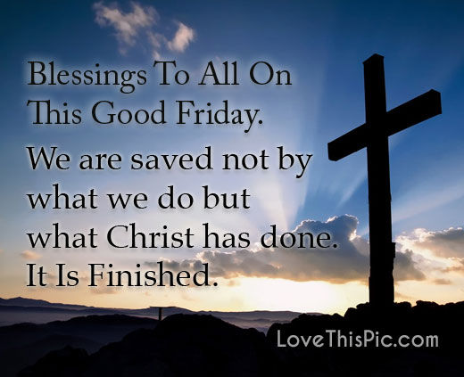 chosen by Roger & Lynne

†

FOR FIRST LIGHT, EASTER SATURDAY 11TH APRIL AT 8pm.

RENEWAL OF BAPTISMAL VOWS

If there are no baptisms or confirmations at the Easter Vigil, the Renewal of Baptismal Vows takes place after the Service of Lessons or the Sermon. On other occasions, the Renewal of Vows follows the Sermon.

The people stand. The Celebrant addresses the Congregation in these or similar words

Through the Paschal mystery, dear friends, we are buried with Christ by Baptism into his death, and raised with him to newness of life. I call upon you, therefore, now that our Lenten observance is ended, to renew the solemn promises and vows of Holy Baptism, by which we once renounced the devil and all his works, and promised to serve God faithfully in his one holy catholic and apostolic Church.

Do you, here in the presence of God and the Church, renew the solemn promises and vows made at your Baptism and commit yourself to keep them?

People I do.

Bishop Do you renounce the devil and all the spiritual forces of wickedness that rebel against God?

People I renounce them.

Bishop Do you renounce the empty promises and deadly deceits of this world that corrupt and destroy the creatures of God?

People I renounce them.

Bishop Do you renounce the sinful desires of the flesh that draw you from the love of God?

People I renounce them.

Bishop Do you turn to Jesus Christ and confess him as your Lord and Saviour?

People I do.

Bishop Do you joyfully receive the Christian Faith, as revealed in the Holy Scriptures of the Old and New Testaments?

People I do.

Bishop Will you obediently keep God’s holy will and commandments, and walk in them all the days of your life?

People I will, the Lord being my helper.

The Celebrant continues
Let us now reaffirm our faith in the words of the ancient baptismal confession, the Apostles’ Creed.

Celebrant Do you believe and trust in God the Father?

People I do. I believe in God, the Father almighty, creator of heaven and earth.

Celebrant Do you believe and trust in Jesus Christ?

People I do. I believe in Jesus Christ, his only Son, our Lord. He was conceived by the Holy Spirit and born of the Virgin Mary. He suffered under Pontius Pilate, was crucified, died, and was buried. He descended to the dead. On the third day he rose again. He ascended into heaven, and is seated at the right hand of the Father. He will come again to judge the living and the dead.

Celebrant Do you believe and trust in the Holy Spirit?

People I do. I believe in the Holy Spirit, the holy catholic Church, the communion of saints, the forgiveness of sins, the resurrection of the body, and the life everlasting. Amen.

The Celebrant concludes the Renewal of Vows as follows: Let us pray.

Almighty God, you have built your Church upon the foundation of the Apostles and Prophets, Jesus Christ himself being the chief cornerstone: Grant us so to be joined together in unity of spirit by their doctrine, that we may be made a holy temple acceptable to you; through Jesus Christ our Lord, who lives and reigns with you and the Holy Spirit, one God, world without end. Amen.

THANK YOU FOR JOINING OUR EASTER 2020 MEDITATION AND FOR
PRAYING THESE PRAYERS TOGETHER

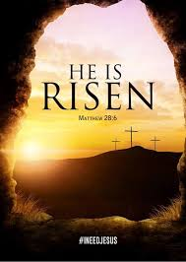

St Michael & All Angels Church, Birchwood, Hatfield, Herts. UK

